**Work-Life Balance and Engagement Analysis Report**

**Introduction**

To effectively utilize your Work-Life Balance and Engagement Analysis Dashboard using Power BI, we'll break down the steps and provide a detailed explanation of each component, along with how to analyse and interpret the data. The report aims to analyse the current state of work-life balance, job involvement, relationship satisfaction, and overtime work distribution across the organization. The goal is to identify areas of improvement and develop strategies to enhance employee well-being and satisfaction.

**Preparation and Analysis**

**1. Review the Work-Life Balance Rating**

**Objective:** Examine the average work-life balance rating across the organization and identify trends or discrepancies.

**Steps:**

* **Data Visualization & Departmental Breakdown:** Create a bar chart to display the average work-life balance rating by Department.

**Analysis:**

* Look for departments with significantly lower work-life balance ratings.

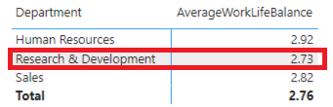

* Identify trends such as work Life Balance Rate, Year at the company & Department.
* Compare the ratings by Job role.

By following these steps, you can effectively analyse work-life balance ratings in Power BI, identifying trends and periods where ratings may drop, and take necessary actions to address issues proactively.

**Power BI Implementation:**

* Use the **AVERAGE** function in Power BI to calculate the average work-life balance rating.
* Create a slicer to filter the data by department or employee group (Job Role).

**2. Assess Job Involvement**

**Objective:** Analyse the average job involvement metric to understand employee engagement.

**Steps:**

* **Data Visualization:** Display the average job involvement score using a bar chart
* **Correlations:** Use Line Column Chart to identify correlations between job involvement and other factors such as department or job role.
* **Comparative Analysis:** Compare job involvement scores across different departments, Job Involvement job roles using a Cluster Column chart.

**Analysis:**

* Identify departments with lower job involvement.

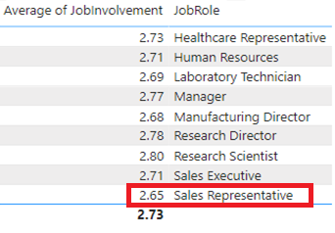

* Look for patterns indicating high job involvement in specific roles.
* Correlate job involvement scores with work-life balance ratings.

**Power BI Implementation:**

* Calculate the average job involvement using the AVERAGE function.
* Use scatter plots to visualize correlations, incorporating filters for department and job role.

**3. Evaluate Relationship Satisfaction**

**Objective:** Review the average relationship satisfaction score to gauge the quality of workplace relationships

**Analysis:**

* Identify departments with lower relationship satisfaction.

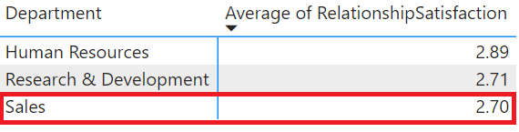

* Investigate potential causes for lower satisfaction in specific areas.
* 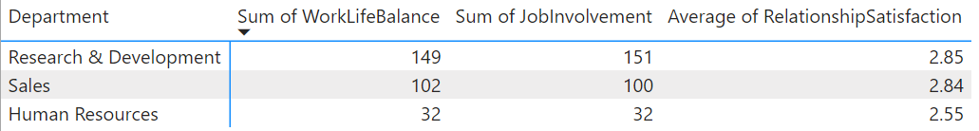Compare relationship satisfaction scores with other metrics like work-life balance and job involvement.

**Power BI Implementation:**

* Calculate the average relationship satisfaction score.
* Use a matrix to break down the scores by department (refer above screenshot)

#### 4. Examine Overtime Work Distribution

**Objective:** Explore the distribution of employees who work overtime compared to those who don't.

**Steps:**

* **Data Visualization:** Create a pie chart or bar chart to show the proportion of employees working overtime versus those who don't.
* **Departmental Breakdown:** Use a stacked bar chart to display overtime distribution by department or role.
* **Impact Analysis:** Correlate overtime work with work-life balance and job satisfaction metrics using scatter plots.

**Analysis:**

* Identify departments or roles with high overtime work.

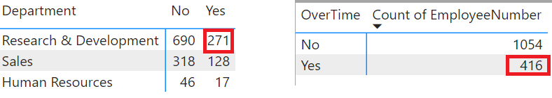

* Assess the impact of overtime on work-life balance and job satisfaction.
* Look for trends indicating when overtime work is most common

**Power BI Implementation:**

* Use calculated fields to identify employees working overtime.
* Create visualizations to display overtime distribution and its correlation with other metrics.

**5. Identify Areas for Improvement**

**Objective:** Based on the analysis, identify areas for improvement in work-life balance, job involvement, relationship satisfaction, and overtime work.

**Steps:**

* **Highlight Key Findings:** Use Power BI bar charts to highlight areas needing attention.
* **Purpose**: Identify departments, roles, or groups with the lowest scores in work-life balance, job involvement, relationship satisfaction, and high overtime.

Lower in work- life Balance, Job Involvement and Relationship Satisfaction

* **Department – Human Resource**
* **Role - Manager**

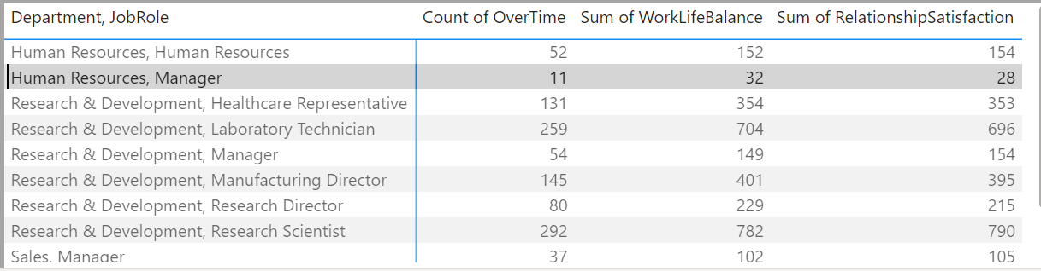

High overtime

* **Department- Sales**
* **Job Role -Sale Executive**

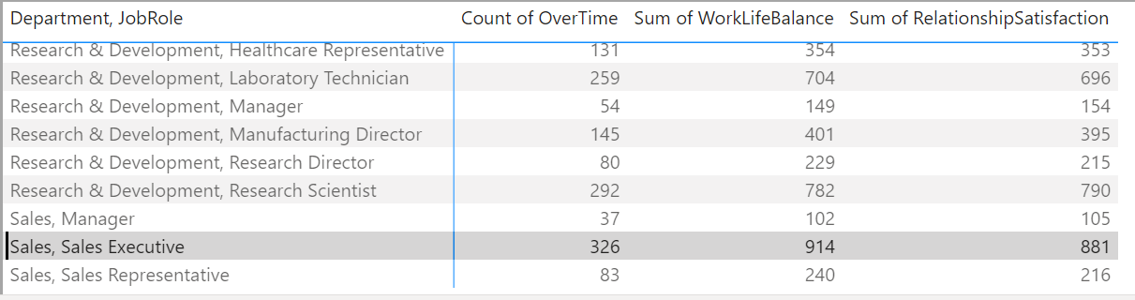

* **Root Cause Analysis:** Investigate underlying causes for low scores in specific metrics.

|  |  |  |
| --- | --- | --- |
| **Departments** | **Job Role** | **Average of Work-Life Balance** |
| **Research & Development** | Manager | 2.76 |
| Research Director | 2.86 |
| Manufacturing Director | 2.77 |
| Research Scientist | 2.68 |
| HealthCare Representative | 2.70 |
| Laboratory Technician | 2.72 |
| **Human Resources** | Manager | 2.91 |
| Human Resource | 2.92 |
| Manager | 2.76 |
| **Sales** | Sales Executive | 2.80 |
| Sales Representative | 2.89 |

**Interpretation of the Matrix:**

The matrix will display the average scores for work-life balance, daily rate, job involvement, and relationship satisfaction for each combination of department and job role, split by overtime status.

**Analysis:**

* **Identify Low Scores:** Look for rows (departments and job roles) where the average scores for work-life balance, job involvement, and relationship satisfaction are lower, especially in the "Yes" column for overtime.
* **Compare Daily Rate:** Compare the daily rates between the "Yes" and "No" columns for overtime to see if there is a significant difference.
* **Develop Actionable Insights:** Provide recommendations for improving work-life balance and engagement.
* **Departments with Low Work-Life Balance Scores:** Identify departments where the work-life balance score is significantly lower when employees work overtime.

For example, if the **HealthCare Representative in R&D Department** shows a lower work-life balance score in the **Yes** column for overtime, this indicates a potential issue with workload or work-life balance policies.

* **Roles with High Overtime Impact:** Compare job roles to see which ones have the most significant drop in work-life balance and job involvement when overtime is required.

For example, if **Sales Representatives** have a notable decrease in work-life balance and job involvement scores when working overtime, it suggests a need for better workload management or support. Let's analyse the provided data for a specific department and role, such as Sales Representatives:

* + Average Daily Rate (No Overtime): 858.13
  + Average Daily Rate (Overtime): 792.32
  + This indicates a lower average daily rate for Sales Representatives when overtime is factored in, which might suggest higher workload affecting work-life balance negatively.

**Actionable Insights:**

Based on the analysis, here are potential actionable insights:

* **Address Overtime Policies:** Review and possibly adjust overtime policies to reduce workload and improve work-life balance, especially in departments or roles showing lower scores.
* **Employee Support:** Provide resources and support for managing workload and stress, particularly in high-demand roles identified through the analysis.

By using Power BI's capabilities to visualize and analyse these metrics, organizations can gain valuable insights into factors influencing work-life balance and take proactive steps to improve employee satisfaction and well-being.

**6. Take Action**

**Objective:**

Develop strategies for enhancing work-life balance and engagement within the organization.

**Steps:**

**Strategy Development**

* **Collaborate with HR and Management to Develop Policies or Initiatives**
* ***Approach***: Engage stakeholders to identify key areas for improvement based on analysis.
* ***Action***: Develop policies, programs, or initiatives targeting work-life balance and engagement.

**Implementation**

* **Roll out Initiatives Aimed at Improving Identified Areas**
* ***Approach***: Implement planned strategies and initiatives effectively.
* ***Action***: Execute programs and monitor their impact on work-life balance and engagement.

**Communication**

* **Communicate Changes to Employees and Gather Feedback**
* ***Approach***: Ensure transparency and involve employees in the process.
* ***Action***: Communicate changes clearly, gather feedback, and adjust strategies as necessary.

**7. Regular Monitoring**

**Objective:** Continuously monitor work-life balance and engagement metrics.

**Steps:**

* ***Dashboard Updates*:** Regularly update Power BI dashboards with new data.
* ***Trend Analysis*:** Use trend lines and historical data to track progress.
* ***Adjust Strategies*:** Make adjustments based on ongoing analysis and employee feedback.

**Conclusion:** Regular monitoring and proactive management of work-life balance and engagement metrics are crucial for fostering a positive work environment and reducing attrition risk.

By following these steps and utilizing Power BI effectively, stakeholders can gain valuable insights and take proactive measures to enhance employee well-being and satisfaction.